BOTANICAL ART
Distance Learning Course Outline

TUTOR: Leonie Norton
BA/VisArt, BFA(Hons)Scientific Plant Illustration, Grad.Dip.VET(Adult Educ)

Learn to draw and paint plants and flowers. Enjoy the beauty of botanical art. Explore pencil and watercolour techniques, including the principles of tone, highlights, composition and perspective. Learn to use watercolours, including mixing and layering of colours as well as various techniques. Work at your own pace. This course is suitable for all levels of ability. Develop new skills or extend existing skills.

STAGE I - DRAWING

- Module 1
- What is botanical art?
- Course Content
- Drawing Materials and Techniques
- Light Source and Reflected Light
- Tonal Values

Module 2
- Drawing Leaves and Foreshortening
- Perspective
- Using tonal and reflected light to
create a three-dimensional illusion
- Assignments
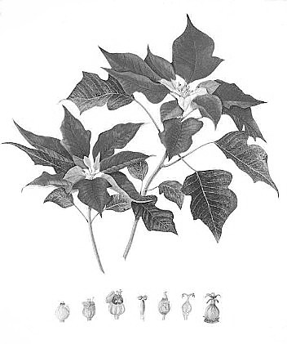

Module 3 – Part 1: Master Drawing

The Master Drawing:
- Using a Drawing Board
- The Subject:
  - Degrees of difficulty
  - Obtaining Plant Specimens
  - Plant Preservation
- How to begin, Drawing Method
- Composition, Tonal Contrast

- Light Against Dark, Highlights and Shadows
- Assignments

Module 3 – Part 2: Stippling

- Line & Stipple
- Materials & Technique
- Stippling with Colour
- Scientific Illustrations
- Assignment

STAGE II – WATERCOLOUR PAINTING

Module 4: Watercolour
- How to transfer drawing onto watercolour paper
- Watercolour Materials List
- Colour Charts (make 450 colours from 6 primary colours)
- Pre-printed Arches 300gsm watercolour sheets supplied
- Colour matching
- Watercolour Wash technique
- Assignments

Module 5
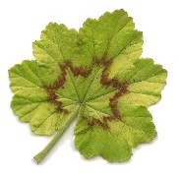
- How to paint leaves
- Step by Step demonstration on painting a
camellia leaf, including various wash intensities
- Dry Brush technique
- How to paint your subject
- Colour Studies, Colour Matching
- Creating Shadow Colours
- Assignments

Module 6
- Botanical Lettering
- How to Paint Waterdrops Step by Step
- Examples of Waterdrops on Leaves and Petals
- Assignments

Module 7
- Plant dissections
- How to complete the Final Painting
- Step by Step Examples of Watercolour Washes
- Personal Critique Checklist
- The Signature
- Removing Creases and Buckling from Watercolour Paper
- Matting and Framing
- Final Painting for Assessment

A CERTIFICATE OF BOTANICAL MERIT IS ISSUED
ON COMPLETION OF COURSE

No refunds issued after enrolment

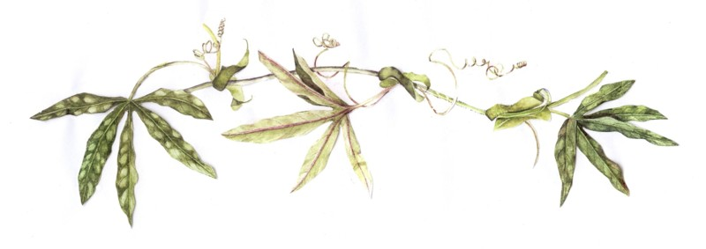

PLANNED LEARNING OUTCOMES

At the end of this course you should be able to:

- Use observational skills to produce a highly detailed drawing
- Complete a detailed tonal drawing, showing at least five tonal values
- Draw a plant with dimension and perspective
- Draw aesthetically pleasing compositions
- Competently implement highlights in a watercolour painting, using both wet and dry painting methods.
- Choose and care for brushes, erasers, paper and drawings
- Mix appropriate colours and colour match the plant you have drawn
- Develop a mastery of watercolour techniques, encompassing colour washes, layering of colours and application of washes
- Correctly label a botanical painting and have some knowledge of framing and the accepted standard for framing a botanical painting.

